IMRAD Template
A plan to work through writing reports for Scientific Research

Section | Scientific Method Step | As Well As…
Introduction | States your hypothesis | Gives purpose of the experiment
Methods | Details how you tested your hypothesis | Clarifies why you performed your study in that particular way
Results | Provides raw (uninterpreted) data collected | Express data in text or table form, as an easy-to-read figure, or as percentages/ratios
Discussion | Considers whether the data you obtained support the hypothesis | Explores the implications of your findings and judges the potential limitations of your design

Before you begin any writing turn to your lab partner and review these questions…
- What did we do in the lab (what was the procedure)?
- Why did we do it that way?
- What did we hope to learn from the experiment?

STEP 1 - INTRODUCTION:

Purpose: What were you trying to learn/understand?

Write your purpose:

The purpose of our model is to inform and protect the community from the health impacts of air pollution, by providing them a clear and easy to understand measure of air quality on a scale. It also raises awareness of environmental issues, promoting actions to improve air quality and safeguard public health.

Hypothesis:

Independent Variable: (I.V.):
Environmental factors such as particulate matter (e.g., PM levels, weather conditions, pollutant concentration).

Dependent Variable: (D.V):
Predicted Air Quality Index (AQI).

Write your hypothesis:
“If environmental factors such as particulate matter and weather conditions significantly affect air quality, then variations in these variables can accurately predict AQI levels in urban areas.”

Identification of Control:
Areas with stable4 AQI data (where variations are minimal) serve as benchmarks to validate our predictions and ensure consistency in the model.

STEP 2 - METHODS
- For the template write out all the steps/actions you took to conduct and complete the experiment in chronological order. Eventually you will take the list and write it out in paragraphs.
Step/Action  *Variables held constant | Rationale  * Some steps/actions warrant explanation because they are unique to this experiment, while others will need no explanation.
1.Historical AQI data from urban areas in the Philippines was gathered from government and international environmental monitoring sources.  2.The dataset was cleaned by removing incomplete entries and outliers to ensure accuracy.  3.Variables such as PM2.5, PM10, temperature, humidity, wind speed, and pollutant concentrations were selected as predictors for AQI.  4.Machine learning models were trained using the dataset to predict AQI based on the selected variables.  5.The predictive model was tested using unseen data to assess its accuracy and reliability. | 1.Cleaning the dataset insures reliability and removes anomalies.  2.Using machine learning allows us to identify complex relationships between variables and AQI that might not be immediately apparent.  3.Testing the model on new data ensures it can perform well in real-world applications.

STEP 3 - RESULTS

- While looking over your results collected, think about what trends emerged or what findings you made.
- Specifically look for data, which relates significantly to the hypothesis.
- Report the facts.

1. ** Circle what you are using** | Describe the results obtained
Line Graph  Bar Graph  Table  Diagram  Histogram  Pie Graph  Picture | 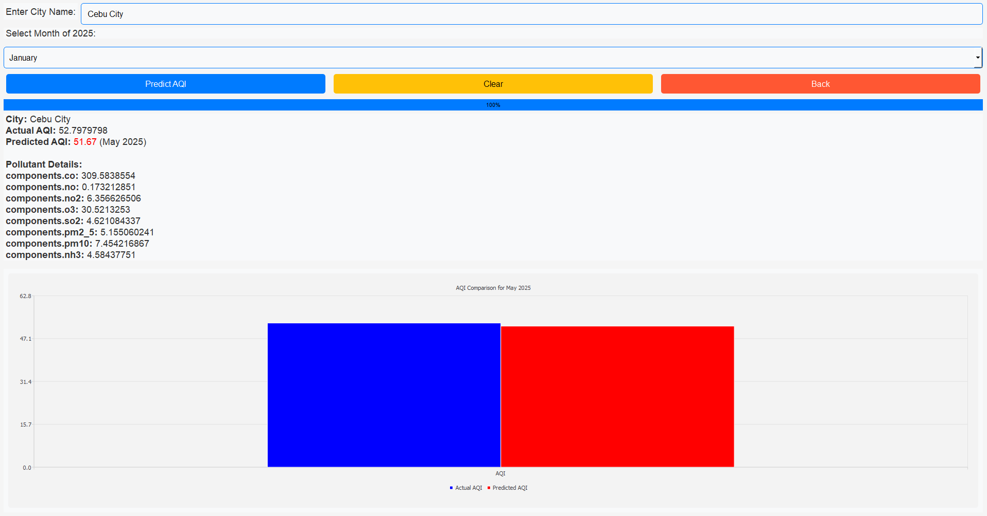  In this graph it represents the actual and the predictions of the Air Quality Index. We can see also the Pollutants Details that causes air pollutions.

2. ** Circle what you are using** | Describe the results obtained
Line Graph  Bar Graph  Table  Diagram  Histogram  Pie Graph  Picture | 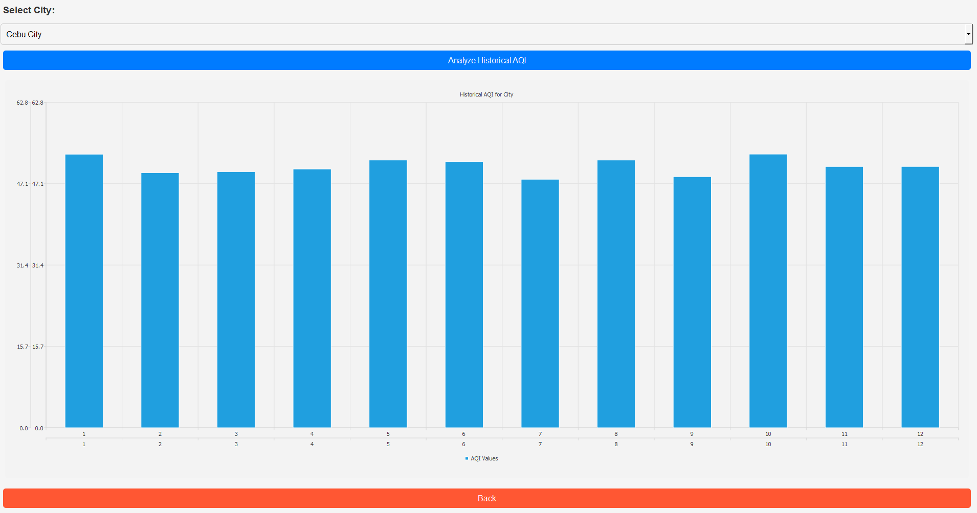  This chart visualize the Historical Data.

3. ** Circle what you are using** | Describe the results obtained
Line Graph  Bar Graph  Table  Diagram  Histogram  Pie Graph  Picture | 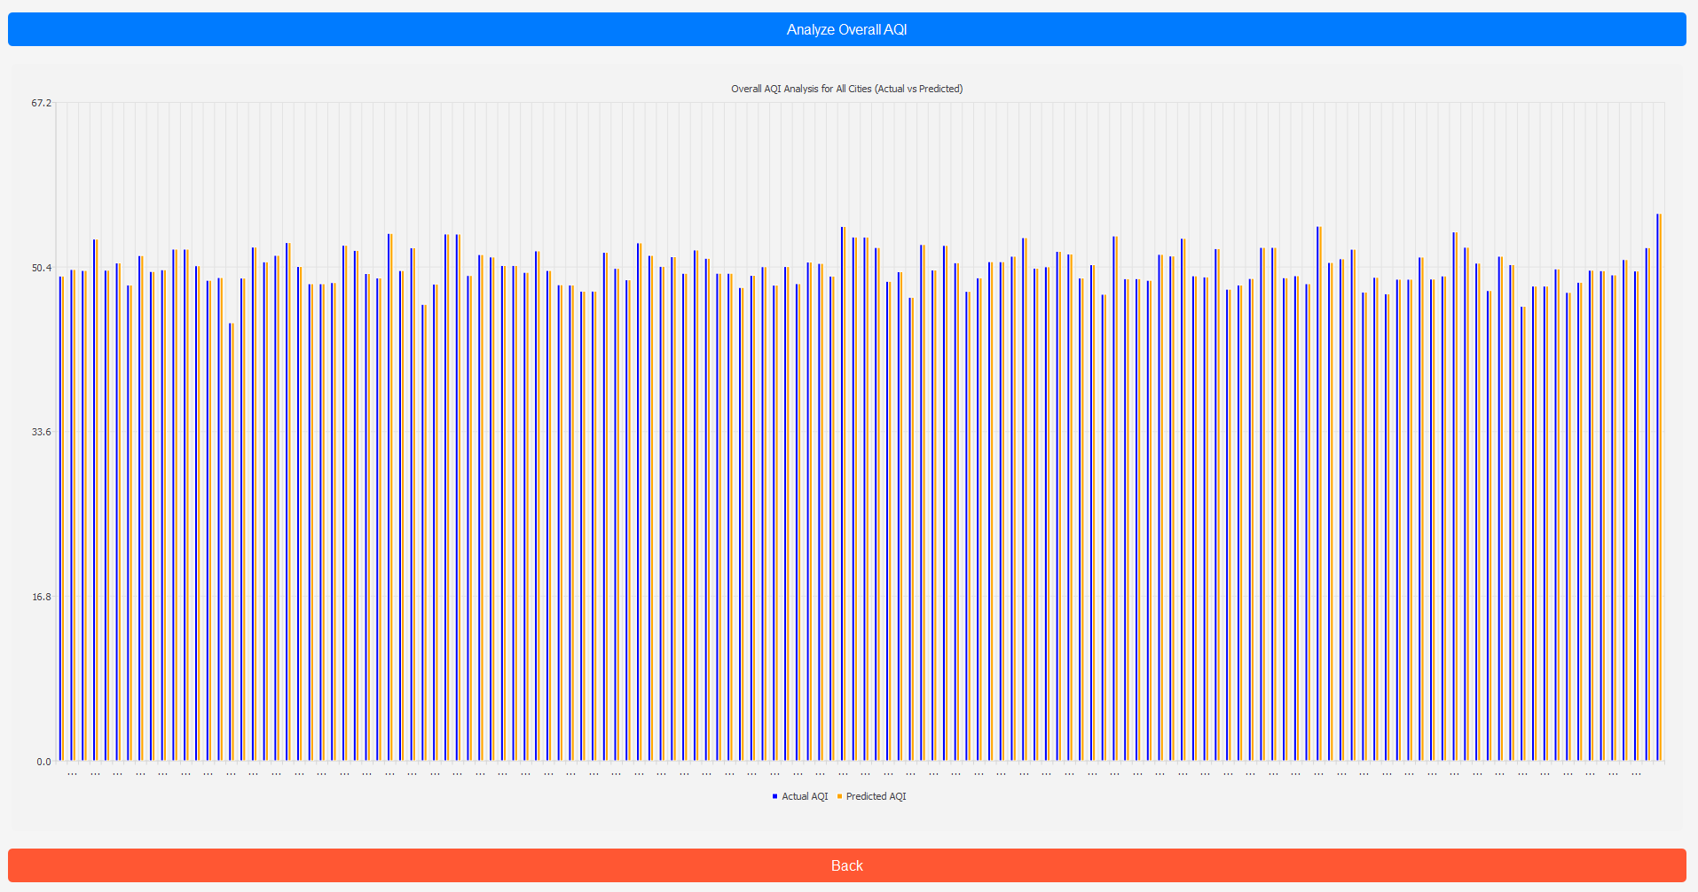  This graph represents the overall AQI analysis for all cities (actual vs. predicted).

4. ** Circle what you are using** | Describe the results obtained
Line Graph  Bar Graph  Table  Diagram  Histogram  Pie Graph  Picture | 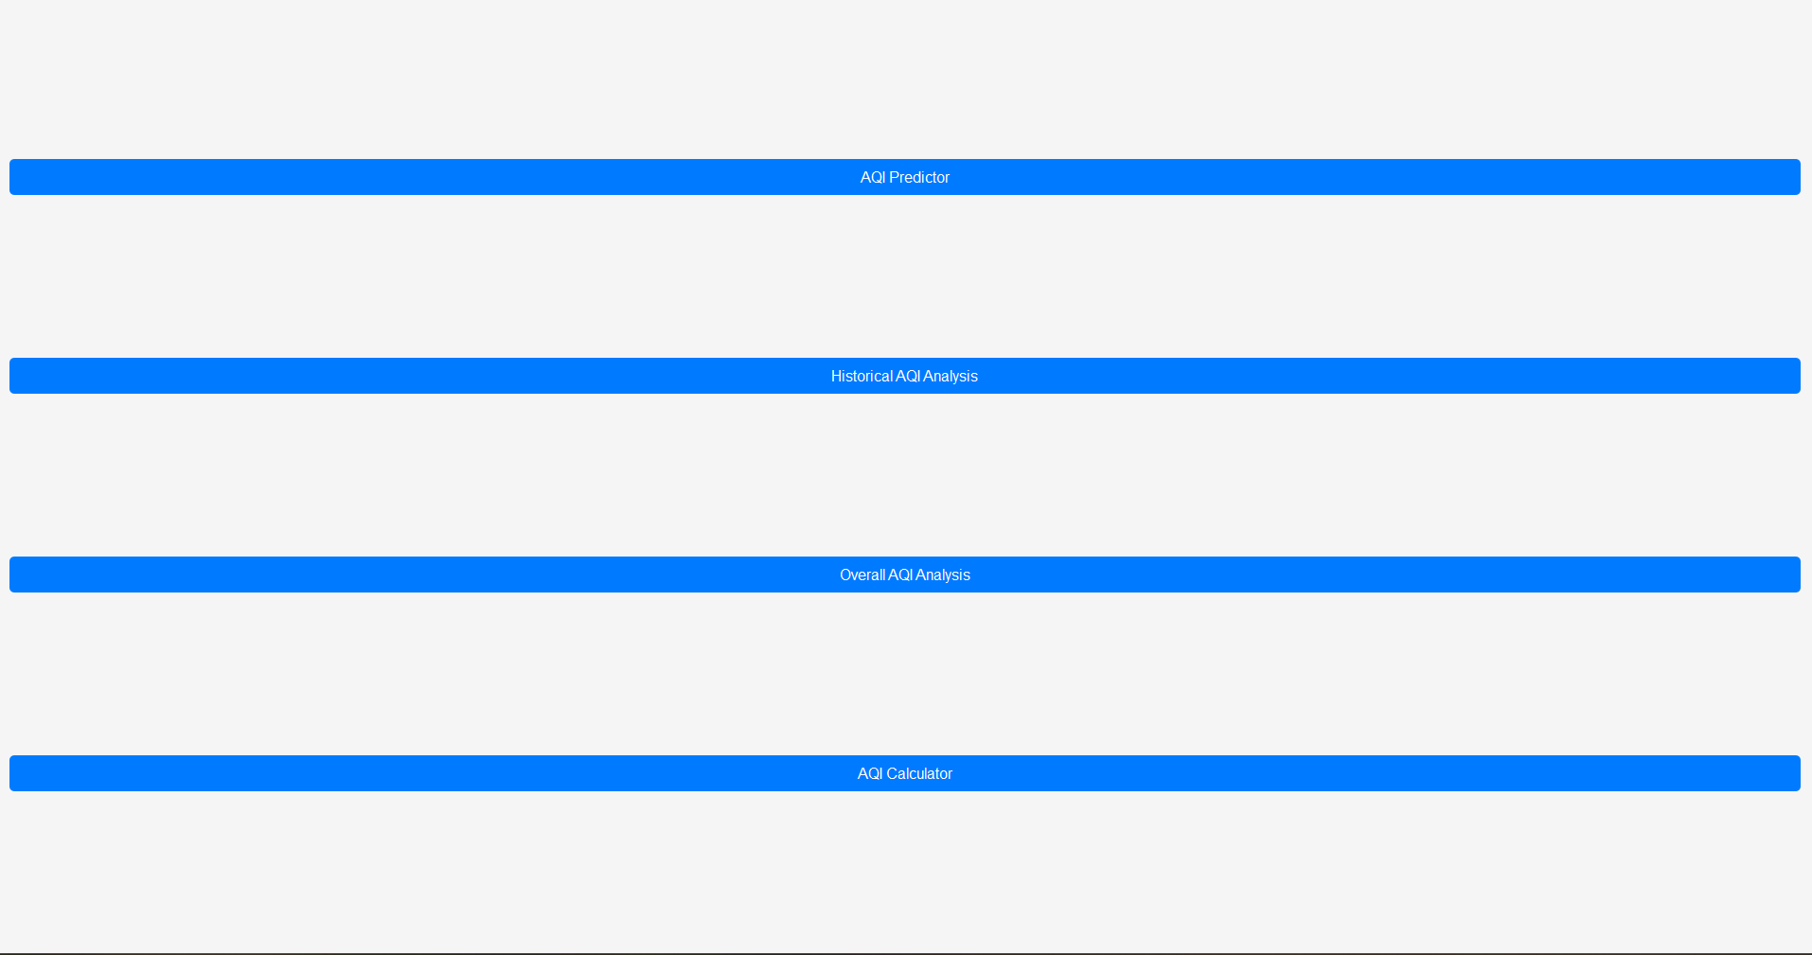  This is the main interface in which the user can select either AQI predictor, Historical Data, Overall AQI analysis, and AQI calculator.

** In addition, for each table, visual, or figure used in the results section of the report, you will need to provide a short paragraph, generally just a few lines, that describes the results obtained in the experiment.
STEP 4 - DISCUSSION
- In this section of the report explain if the data supports the hypothesis.
- Acknowledge any anomalies from what was expected.
- Make conclusions, based on findings in the experiment, about the process studied.

Does the data collected support the hypothesis?
- Yes, the hypothesis was supported. The results show that environmental factors, such as particulate matter levels and weather conditions, have a noticeable impact on the Air Quality Index (AQI). Predictive models built using this data revealed a strong connection between these factors and AQI levels, highlighting their influence.

Were there any anomalies or unexpected results?
- There were some unexpected results. In certain areas, AQI values spiked unpredictably due to sudden factors like construction activities or wildfires that weren’t included in the dataset. These anomalies make it harder for the model to maintain accuracy in those cases.

Were there weaknesses in the experiment?
- One major challenge was the lack of complete data from some urban areas, as not all cities in the Philippines have consistent monitoring for all relevant environmental factors. Other issues were the difficulty in accounting for unforeseen events, such as volcanic eruptions or unrecorded pollution sources, which could significantly affect AQI levels.

How would you improve the experiment?

- To make the predictions more accurate, future efforts could use real-time data collection and satellite monitoring to cover more environmental conditions. Expanding the dataset to include more under – monitored areas and factoring in emergency events, like typhoons or forest fires, would also make the model more reliable and robust.

What is your conclusion based on your findings?
- The study highlights how environmental factor play a crucial role in determining AQI levels in urban areas. Predictive models based on these variables can provide reliable forecasts under normal conditions. However, unexpected anomalies show that there’s still room for improvement. To make the predictions more comprehensive, we need to include real-time data and account for unpredictable events in the future.

